LECTURE 5
INTER PROCESS COMMUNICATIONS AND MODELS DETAIL

Interprocess Communication (IPC)
Definition
Interprocess Communication (IPC) is a mechanism provided by the operating system that allows processes to communicate with each other and synchronize their execution.
IPC is necessary when processes cooperate by sharing data or coordinating tasks. Without IPC, cooperating processes cannot function correctly.
Why IPC is Needed
1. Information Sharing
Sometimes multiple processes need access to the same data.
Example:
- Multiple programs accessing the same file
- A database used by different applications
IPC ensures that data is shared safely and consistently.
2. Computation Speedup
A large task can be divided into smaller subtasks and executed by multiple processes simultaneously (parallel execution).
This results in:
- Faster execution
- Better CPU utilization
- Improved performance in multi-core systems
3. Modularity
A system can be designed as separate processes, each performing a specific function.
Advantages:
- Easier development
- Easier debugging
- Better maintenance
- Clear separation of tasks
4. Convenience
Users can perform multiple activities at the same time.
Example:
- Printing a document while browsing the internet
- Listening to music while writing an assignment
IPC allows background and foreground processes to coordinate properly.

Independent and Cooperating Processes
Processes in an operating system can be classified into two types:
- Independent Processes
- Cooperating Processes
Independent Process
Definition
An independent process is a process that does not share data or resources with other processes.
Characteristics
- Does not affect other processes
- Is not affected by other processes
- Does not require communication
- Does not require synchronization
- Executes completely on its own
Example
Running a calculator application alone without interacting with other programs.
Cooperating Process
Definition
A cooperating process is a process that shares data or resources with other processes.
Characteristics
- Can affect other processes
- Can be affected by other processes
- Requires communication
- Requires synchronization
- Depends on other processes for proper execution
Example
Producer and Consumer processes sharing a common buffer.
Comparison Between Independent and Cooperating Processes
Independent Process:
- No data sharing
- No communication required
- No synchronization needed
- Fully self-contained
Cooperating Process:
- Shares data/resources
- Requires IPC
- Needs synchronization to prevent errors
- Interdependent with other processes

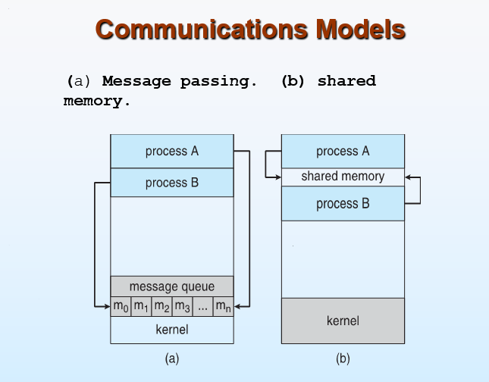
Shared Memory
Concept
Shared Memory is an IPC mechanism in which two or more processes communicate by accessing a common memory area.
- The operating system creates a shared memory segment.
- The processes that want to communicate attach to this memory.
- After attachment, processes can read and write directly to the shared area.
- The OS is not involved in every data transfer after the memory is set up.
Because processes directly access the same memory, communication is very fast compared to message passing.
Shared memory is suitable when:
- Processes run on the same system.
- High-speed communication is required.
Synchronization Issues
Since multiple processes access the same memory, problems can occur if they try to modify data at the same time.
Major issues:
- Race Condition
Occurs when two processes access and modify shared data simultaneously, causing inconsistent results.
- Mutual Exclusion
Only one process should access the critical section (shared data) at a time.
- Data Consistency
Data must remain correct and valid after concurrent access.
To solve these issues, synchronization mechanisms are used, such as:
- Semaphores
- Mutex locks
- Monitors
Shared memory is fast but requires careful synchronization to prevent errors.

Message Passing
Concept
Message Passing is an IPC mechanism where processes communicate by sending and receiving messages.
- Processes do not share memory.
- Communication happens through system calls.
- The operating system manages message transfer and synchronization.
This model is simpler and safer because processes remain isolated.
send() and receive() Operations
Message passing uses two basic primitives:
- send(message)
Used by a process to send a message.
- receive(message)
Used by a process to receive a message.
Communication occurs through these operations, usually managed by the kernel.
Fixed vs Variable Message Size
- Fixed Message Size
  - Every message has the same predefined size.
  - Easier to implement.
  - May waste memory if messages are small.
- Variable Message Size
  - Messages can have different sizes.
  - More flexible.
  - Slightly more complex to manage.
OS Responsibility
In message passing, the operating system:
- Establishes communication links.
- Stores messages in queues.
- Manages synchronization.
- Delivers messages to the correct process.
- Handles blocking and non-blocking communication.
The OS acts as a mediator between communicating processes.
Examples
Common examples of message passing mechanisms:
- Pipes
- Message Queues
- Sockets

Message Passing – Communication Link Issues
In message passing, a communication link is the logical connection that allows two or more processes to exchange messages.
When designing or analyzing message passing, several important issues must be considered.
1. Link Establishment
How is the communication link created?
There are two main ways:
Direct Communication
- Processes explicitly name each other.
- A link is automatically established between the sender and receiver.
Indirect Communication
- Communication occurs through a mailbox or message queue.
- Processes send to and receive from the mailbox instead of naming each other directly.
2. Number of Processes per Link
Can more than two processes share a link?
Direct Communication
- A link is associated with exactly two processes.
Indirect Communication
- Multiple processes can share the same mailbox.
- Supports many-to-many communication.
3. Number of Links Between Processes
Direct Communication
- Only one link exists between each pair of processes (in each direction).
Indirect Communication
- Multiple links can exist because processes may share several mailboxes.
4. Capacity of Link
Capacity refers to how many messages can be stored in the communication link (buffer size).
Three possibilities:
Zero Capacity
- No buffering.
- Sender must wait until receiver receives the message.
- Also called synchronous communication.
Bounded Capacity
- Finite buffer size.
- Sender waits only if the buffer is full.
Unbounded Capacity
- Infinite buffer (theoretical).
- Sender never waits.
5. Message Size
Messages can be:
Fixed Size
- All messages have the same size.
- Easier to implement.
Variable Size
- Messages can differ in length.
- More flexible but more complex.
6. Direction of Communication
Unidirectional
- Communication flows in one direction only.
Bidirectional
- Communication flows in both directions between processes.

Implementation of Communication Link
A communication link is the mechanism that allows two processes to exchange messages.
When designing this link, we must consider:
- Physical Implementation (How it is supported at hardware/system level)
- Logical Implementation (How communication behaves at OS level)
1) Physical Implementation
This refers to the actual medium used to carry data between processes or systems.
1. Shared Memory (Physical Medium)
Here, communication happens through memory inside the same machine.
- The OS may allocate a memory region.
- Messages are stored in RAM.
- Both processes indirectly use that memory through the kernel.
This is common when processes run on the same system.
Important:
In message passing, processes do not directly access this memory — the kernel controls it.
2. Hardware Bus
A hardware bus is an internal communication pathway inside a computer.
Examples:
- System bus
- Data bus
Processes communicate using signals and data transfer over this bus.
This is low-level communication handled by the OS and hardware.
3. Network
If processes are on different machines:
- Communication happens through a network.
- Data is transmitted as packets.
- Uses network protocols (like TCP/IP).
Example:
Client-server applications over the internet.
2) Logical Implementation
This refers to how communication is structured from the operating system’s perspective.
It defines the behavior of the communication link.
1. Direct or Indirect Communication
Direct Communication
- Processes explicitly name each other.
- Example:
send(P, message)
- Link is automatically created between two specific processes.
- Usually one-to-one communication.
Indirect Communication
- Communication happens via mailbox or message queue.
- Processes send to and receive from the mailbox.
- Multiple processes can share the same mailbox.
- Supports many-to-many communication.
2. Synchronous or Asynchronous Communication
This defines whether processes wait during communication.
Synchronous (Blocking)
- Sender waits until message is received.
- Receiver waits until message is available.
- Strong synchronization between processes.
Asynchronous (Non-blocking)
- Sender continues execution after sending.
- Receiver may receive immediately or later.
- More flexible and faster.
3. Automatic or Explicit Buffering
This defines how messages are stored temporarily.
Automatic (Implicit) Buffering
- OS automatically maintains a buffer (queue).
- Messages are stored until received.
- Sender usually does not manage the buffer.
Explicit Buffering
- Process provides its own buffer.
- Sender or receiver manages memory.
- Requires more control from programmer.

Difference between (Shared Memory in Message Passing) and (Shared Memory as an IPC Model)
Example Scenario
Process A produces data.
Process B consumes that data.
Example:
Process A generates numbers.
Process B prints those numbers.
Case 1: Message Passing Model
How it works:
Process A does:
send(10)
What happens internally:
- OS receives the send() request.
- OS stores "10" in a kernel message queue (in RAM).
- Process B calls receive().
- OS copies "10" from kernel memory to Process B.
Important:
- The kernel buffer is in shared RAM.
- But Process A and B cannot directly access that memory.
- Only the OS can.
Think of it like:
A → gives data to OS
OS → stores it
OS → gives it to B
Processes never touch the same memory.
Case 2: Shared Memory Model
How it works:
- OS creates a shared memory segment.
- Both Process A and B attach to it.
- Process A writes 10 into shared memory.
- Process B directly reads 10 from the same memory location.
Here:
Both processes are reading/writing the SAME memory block.
No copying through kernel every time.
Think of it like:
A and B both working on the same whiteboard.
Now The Confusing Part
In Message Passing:
Yes, the OS stores messages in RAM.
But that RAM is private to the kernel.
Processes cannot directly:
- Read from it
- Write to it
- Modify it
So it is NOT the shared memory IPC model.
Very Simple Analogy
Shared Memory Model:
Two students writing on the same notebook.
Message Passing Model:
Student A gives paper to teacher.
Teacher gives it to Student B.
The teacher’s desk is memory.
But students do not directly access the teacher’s desk.

. Automatic & Explicit Buffering
Buffering refers to the temporary storage of messages during communication between processes.
It determines how messages are stored before being received.
1) Automatic (Implicit) Buffering
In automatic buffering, the operating system automatically maintains a buffer (queue) for messages.
How it works:
- When a process sends a message, the OS stores it in a system-managed queue.
- The sender does not need to provide memory.
- The receiver collects the message when it is ready.
Characteristics:
- Buffer is managed by the OS.
- Easier for programmers.
- Common in asynchronous message passing.
- Sender may continue execution without waiting (if buffer is not full).
Example:
Message queues in operating systems.
2) Explicit Buffering
In explicit buffering, the process itself provides the buffer for storing messages.
How it works:
- The sender or receiver specifies where the message should be stored.
- The OS does not automatically manage a queue.
- Programmer controls memory management.
Characteristics:
- More control over memory usage.
- Can be used in synchronous communication.
- Requires careful programming.
Key Difference:
Automatic Buffering → OS manages storage.
Explicit Buffering → Process manages storage.

Producer–Consumer Problem
Definition
The Producer–Consumer problem is a classic synchronization problem in operating systems.
It involves:
- A Producer process that generates data.
- A Consumer process that uses that data.
- A shared buffer where produced data is stored before consumption.
The buffer acts as a temporary storage area between producer and consumer.
Unbounded Buffer
In an unbounded buffer:
- There is no practical limit on buffer size.
- Producer never waits because buffer never becomes full.
- Consumer only waits if buffer is empty.
This is theoretical and not realistic in actual systems.
Bounded Buffer
In a bounded buffer:
- The buffer has a fixed size.
- Producer must wait if buffer is full.
- Consumer must wait if buffer is empty.
This is the realistic and commonly used case.
Problems in Producer–Consumer
1) Buffer Full
If the buffer is full:
- Producer must stop producing.
- It must wait until consumer removes some items.
Otherwise, data may be overwritten.
2) Buffer Empty
If the buffer is empty:
- Consumer must wait.
- It cannot consume data that does not exist.
3) Mutual Exclusion
Producer and consumer cannot access the buffer at the same time.
If both try to modify the buffer simultaneously:
- Data corruption may occur.
- Inconsistent results may occur.
Only one process should access the critical section (buffer) at a time.
4) Synchronization
Proper coordination is required so that:
- Producer waits when buffer is full.
- Consumer waits when buffer is empty.
- Only one process accesses the buffer at a time.
This is achieved using synchronization tools such as:
- Semaphores
- Mutex locks
- Monitors

Direct Communication
Concept and Flow
In direct communication, processes must explicitly name each other when sending and receiving messages. This means the sender knows exactly which process it is communicating with, and the receiver may also specify from which process it wants to receive a message.
The communication flow is simple and direct:
Process A → send(P, message) → Operating System → Process P
The sender calls send(P, message), where P is the receiving process. The operating system delivers the message directly to process P. The receiver may call receive(Q, message) if it wants to receive a message specifically from process Q.
Thus, the flow is:
Sender → OS → Specific Receiver
Properties
In direct communication, a link is automatically established when one process names another in a send or receive operation. Each link is associated with exactly one pair of processes, meaning communication is strictly one-to-one. Between any two processes, only one logical link exists. The link may be unidirectional, where messages flow in one direction only, but it is usually bidirectional, allowing both processes to send and receive messages. However, this method requires processes to know each other's identity, which reduces flexibility.

Indirect Communication
Concept and Flow
In indirect communication, processes do not communicate directly with each other. Instead, they communicate through an intermediate mailbox (also called a port). A mailbox is a logical object that stores messages temporarily and has a unique identifier.
The communication flow works as follows:
Process A → send(A, message) → Mailbox → Operating System → Mailbox → receive(A, message) → Process B
Here, Process A sends a message to the mailbox. The message is stored in the mailbox until another process retrieves it. Process B receives the message by accessing the same mailbox. The sender and receiver do not need to know each other’s identities; they only need to know the mailbox identifier.
Thus, the flow is:
Sender → Mailbox → Receiver
Properties
In indirect communication, a communication link is established only if processes share a common mailbox. Unlike direct communication, a mailbox can be associated with multiple processes, allowing one-to-one, one-to-many, or many-to-many communication. Multiple links can exist between processes if they use different mailboxes. The link may be unidirectional or bidirectional depending on how the mailbox is used. This model is more flexible because processes communicate through the mailbox rather than naming each other directly.

Message Passing – Synchronization
Synchronization in message passing means whether a process must wait during communication or can continue running immediately.
There are two types:
- Blocking (Synchronous)
- Non-blocking (Asynchronous)
1) Blocking (Synchronous)
In blocking communication, a process must wait until the communication is completed.
This creates strong coordination between sender and receiver.
Blocking Send
In blocking send:
- The sender sends a message.
- The sender must wait until the receiver receives it.
- The sender cannot continue its program until that happens.
Flow:
Sender → send() → waits
Receiver → receive() → message delivered
Sender → continues running
So the sender pauses before moving to the next instruction.
Blocking Receive
In blocking receive:
- The receiver tries to receive a message.
- If no message is available, it must wait.
- It continues running only after it gets a message.
Flow:
Receiver → receive() → waits
Sender → send() → message delivered
Receiver → continues running
The receiver pauses until a message arrives.

2) Non-blocking (Asynchronous)
In non-blocking communication, a process does not wait.
It continues running its program immediately after the send or receive call.
Non-blocking Send
In non-blocking send:
- The sender sends the message.
- It does not wait for the receiver.
- It immediately continues to the next instruction.
Flow:
Sender → send() → continues running
Receiver receives later
The sender keeps working without stopping.
Non-blocking Receive
In non-blocking receive:
- The receiver checks for a message.
- If a message is available, it receives it.
- If no message is available, it continues running without waiting.
Flow:
Receiver → receive()
If message exists → process it
If no message → continue program
The receiver never pauses.

Buffering Types
Buffering means how many messages can be stored in the communication link before they are received.
1) Zero Capacity
- No message storage.
- Sender must wait until receiver is ready.
- Communication happens directly.
Flow:
Sender → send() → waits
Receiver → receive() → message transferred immediately
This is always blocking.
2) Bounded Capacity
- Buffer has fixed size (for example, 5 messages).
- Messages are stored temporarily.
- If buffer is full, sender must wait.
- If buffer is empty, receiver must wait.
Flow:
Sender → message stored in buffer (if space available)
Receiver → removes message from buffer
This is the most common type.
3) Unbounded Capacity
- Buffer has no practical size limit (theoretical idea).
- Sender never waits.
- Messages keep getting stored.
Flow:
Sender → send() → continues running
Receiver reads messages later
In real systems, memory is limited, so true infinite buffers do not exist.

Client–Server Communication
Sockets
Definition
A socket is an endpoint for communication between two processes over a network.
It allows a client and a server to communicate by sending and receiving data.
In simple terms, a socket connects two programs running on different machines (or the same machine) through a network.
IP + Port
A socket is identified by:
IP Address + Port Number
IP Address:
- Identifies the device on the network.
Port Number:
- Identifies the specific application or service running on that device.
Example:
161.25.19.8 : 1625
161.25.19.8 → IP address
1625 → Port number
Communication occurs between a pair of sockets:
Client Socket ↔ Server Socket
Well-Known Ports
Ports below 1024 are called well-known ports.
They are reserved for standard services.
Examples:
Port 21 → FTP
Port 23 → Telnet
Port 80 → HTTP
These ports are predefined and commonly used for specific network services.
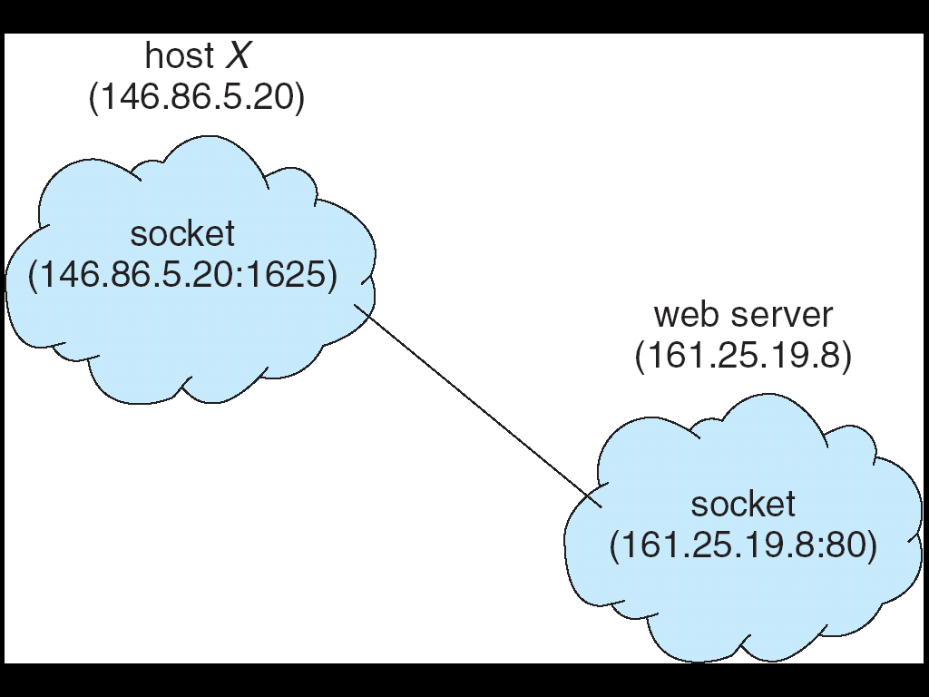
Step-by-Step Socket Flow
Step 1: Server is Ready
The web server machine (161.25.19.8) creates a socket and binds it to:
161.25.19.8 : 80
Port 80 is the standard HTTP port.
This means:
The server is listening for incoming connections on port 80.
Step 2: Client Creates a Socket
Host X (146.86.5.20) creates its own socket:
146.86.5.20 : 1625
Port 1625 is a temporary (ephemeral) port chosen by the OS.
This identifies the client application.
Step 3: Connection Establishment
The client wants to access the web server.
So it connects:
(146.86.5.20 : 1625) → (161.25.19.8 : 80)
Now a connection is established between these two sockets.
Important:
Communication happens between socket pairs, not just IP addresses.
Connection is uniquely identified by:
Client IP + Client Port
Server IP + Server Port
Together they form a unique connection.
Step 4: Data Transfer
Now data flows like this:
Client → sends HTTP request → Server
Server → sends HTTP response → Client
Example:
Client sends:
GET /index.html
Server responds:
HTML page data
Flow:
(146.86.5.20 : 1625)
↓
(161.25.19.8 : 80)
And back:
(161.25.19.8 : 80)
↓
(146.86.5.20 : 1625)
Communication is bidirectional.
Step 5: Connection Close
After data exchange:
- Client or server closes the connection.
- The socket is released.
.
Remote Procedure Calls (RPC)
Definition
Remote Procedure Call (RPC) is a communication mechanism that allows a program to call a procedure (function) on another machine as if it were a local function.
RPC hides the complexity of network communication.
The programmer writes code as if calling a normal function.
Stub
A stub is a small piece of code that acts as a representative of the remote procedure.
It handles communication details between client and server.
There are two types of stubs:
Client Stub
Server Stub (Skeleton)
Client Stub
The client stub:
- Appears like a local procedure to the client.
- Receives function arguments from the client.
- Converts arguments into a transmittable format (marshalling).
- Sends the request to the server.
It hides networking details from the client.
Server Stub (Skeleton)
The server stub:
- Receives the request from the client.
- Converts the transmitted data back to original format (unmarshalling).
- Calls the actual procedure on the server.
- Marshals the result and sends it back to the client.
It acts as a bridge between network and server function.
Marshalling
Marshalling is the process of converting function arguments into a format suitable for transmission (such as a byte stream).
It prepares data to be sent over the network.
Unmarshalling
Unmarshalling is the process of converting transmitted data back into its original form.
It reconstructs the parameters on the receiving side.
Parameter Passing in RPC (Flow)
Scenario
Client wants to call a remote function:
multiply(4, 5)
The actual function exists on the server.
Step-by-Step RPC Flow
Step 1: Client Calls Function
Client program writes:
result = multiply(4, 5)
To the client, it looks like a normal local function call.
Step 2: Client Stub Takes Control
The client stub acts like the multiply function.
It performs:
- Takes parameters (4, 5)
- Marshals them
Converts 4 and 5 into a byte stream format
- Creates a request message:
  - Function name: multiply
  - Parameters: (4, 5)
- Sends the request to the server
Flow so far:
Client Program
→ Client Stub
→ Marshall parameters
→ Send request over network
Step 3: Server Stub Receives Request
The server stub (also called skeleton):
- Receives the byte stream
- Unmarshals it and converts byte stream back into (4, 5)
- Calls the actual server function: multiply(4, 5)
Step 4: Server Executes Function
Server runs:
multiply(4, 5)
Result = 20
The function finishes execution.
Step 5: Server Stub Sends Back Result
Server stub now:
- Marshals the result (20)
- Sends it back to the client
Flow:
Server Function
→ Server Stub
→ Marshall result
→ Send back
Step 6: Client Stub Receives Result
Client stub:
- Receives byte stream
- Unmarshals it
- Returns result (20) to client program
Now the client program gets: result = 20

Remote Method Invocation (RMI)
Definition
Remote Method Invocation (RMI) is a Java-based mechanism that allows a Java program to call methods on objects located on another machine.
It is similar to RPC but specifically designed for Java.
Java-Based Remote Invocation
In RMI:
- A Java object on one machine invokes a method on a remote Java object.
- It supports object-oriented features.
- It allows passing objects (not just simple data).
Flow:
Client Java Object → Remote Method Call → Server Java Object → Result Returned
RMI is used in distributed Java applications.

